**PyBer Bar Challenge**

**Overview of Ride Data:**

PyBer is a ride-sharing application that has a data set with information including: fares, drivers, riders, city type, and date. The company wants a breakdown of the metrics average fare per ride, average fare per drive, and differentiation between city types. To support the company, pandas was used to augment and modify the raw CSV files into data frames that showed the required business metrics. Then using the finalized info the company wanted a chart showing the differentiation between city types. To fulfill this requirement Matlibplot built into python was used. Finally all of the results are used to give executives ideas of how to increase usage of PyBer.

**Ride Data Results:**

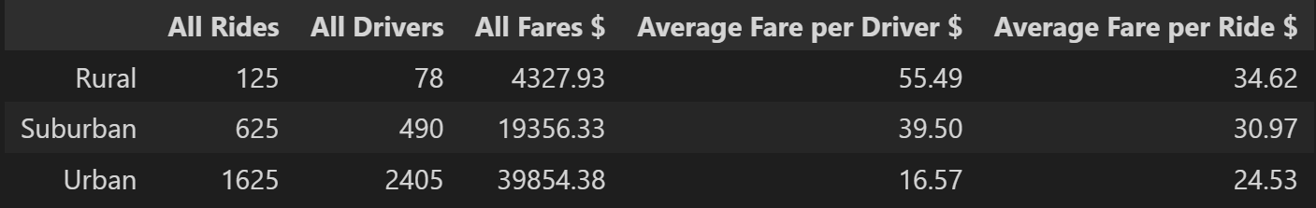

Urban Cities have nearly triple the amount of suburban rides and more than 13x the amount of rides in rural areas. The amount of drivers follows the same trend for the number of rides in the different city types. Is it necessary for the number of rides to be equivalent to the number of drivers?

Notice that rides in rural areas are the most expensive, being 10.5% more than suburban rides and 29.1% than urban rides. The percentage of overall fares breakdown as 62.7%, 30.5%, and 6.8% for urban, suburban, and rural respectively. The average fare for drivers is more than three times higher for rural drivers and 2 times higher for suburban drivers compared to urban drivers.

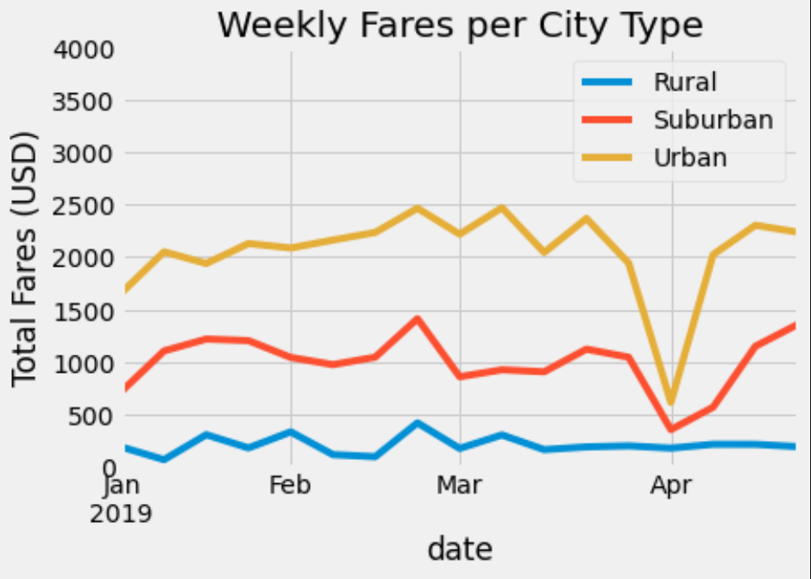

The weekly fares per city type followed the overall positioning from the dataframe above. All areas saw an uptick in usage towards the end of February. However, the beginning of April saw a drastic drop for the urban fares, and suburban fares also dropped. Interestingly the rurals fares did not see that same drop. Towards the end of April urban and suburban fares recovered to their baseline amounts.

**Ride Data Summary:**

The executives of PyBer have asked for three recommendations to address disparities. These recommendations are only being given with a small subset of information without data like the need of rides per area, the demographics of riders, the amount of unfulfilled rides, etc….

**Business Recommendations:**

1. Increase the amount of rural drivers
   1. The average fares the company is paying per driver is astronomical compared to urban areas
      1. Incentive urban drivers to go out into more rural area
   2. Increased drivers in rural areas could also drive the overall fare per ride
      1. Giving the rural population greater financial incentive to use PyBer
2. Run promotions in rural and suburban areas to attract more riders
   1. Offer a rewards program for these demographics
   2. PyBer needs to build strong connection into these demographics since they are less likely to use PyBer
3. Find ways to mitigated large drop offs in fares
   1. Allow rides the be scheduled in advance
   2. Have cheaper fares in their is an overabundance of drivers compared to riders
   3. Promote repeat usage - “Ride five weeks in a row and your next ride is on us”